REPORT FOR: | Pension Board
Date of Meeting: | 30 October 2023
Subject: | LAPFF Engagement and Voting for Quarter Ending June 2023
Responsible Officer: | Sharon Daniels, Interim Director of Finance and Assurance
Exempt: | No
Wards affected: | Not applicable
Enclosures: | Appendix 1 - LAPFF Quarterly Engagement Report for April-June 2023

Section 1 – Summary and Recommendations
This report is a summary of various Environmental, Social & Governance (ESG) engagement and voting issues that the Local Authority Pension Fund Forum (LAPFF).
The Fund is a member of LAPFF, a shareholder engagement group that regularly engages with companies to encourage best practice and effect positive change.

Recommendations:
The Board is requested to comment and note the outcomes achieved by LAPFF through their engagement for quarter ended 30 June 2023.

Section 2 – Report

- The Fund is required to fulfil its fiduciary duty to protect the value of the Fund, with a purpose to meet its pension obligations. Part of this involves consideration of its wider responsibilities in Responsible Investment (RI) as well as how it exercises its influence through engaging as active shareholders.

- LAPFF is a collaborative shareholder engagement group representing most of the Local Government Pension Scheme (LGPS) Funds and UK Pension Pools, including London CIV. LAPFF engages directly with senior management and company boards to ensure they have the right policies in place to create value responsibly.

LAPFF Engagement

- The LAPFF Quarterly Engagement Report can be found at the link below and also attached to this report as Appendix 1. This report details progress on all engagements. Some of the highlights from Q2 are summarised below.
LAPFF_QER02_2023.pdf (lapfforum.org)

- Due to the scale of investment risk and as part of a continued focus on mitigating climate risks, LAPFF has been issuing a series of dedicated climate change voting alerts. These recommend voting positions on climate-related shareholder resolutions with the aim of ensuring companies properly address the climate risks they face. The alerts covered companies in different sectors and centred on climate topics that LAPFF engages on, including transition plans, adequate targets, lobbying, and a just transition. Over the quarter, LAPFF issued climate alerts covering over 50 resolutions with half receiving the backing of 20 percent or more shareholder votes. The scale highlights the support for climate action among responsible investors and delivers a strong message to companies on the need for credible climate action policies and plans.

- The chart below shows how LAPFF engaged over the quarter in relation to the UN Sustainable Development Goals (SDGs).

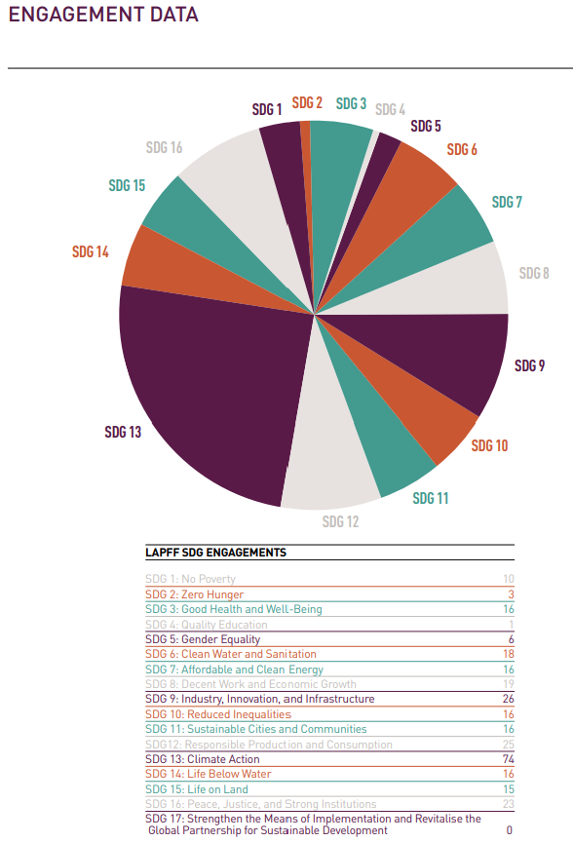

- LAPFF has issued voting alerts for Amazon, Tesla, Meta Platforms, and Alphabet, largely supporting ESG shareholder resolutions. LAPFF continues to have concerns about corporate governance and social practices at large US technology companies, who, in LAPFF’s experience, do not have a culture of engaging with investors as UK and Australian companies do. None of the technology companies who were issued draft alerts prior provided comments or responses to LAPFF and LAPFF continues to seek ways to engage.

- During the quarter ending 30 June 2023, LAPFF engaged with 84 companies domiciled across more than 10 jurisdictions. Most of this engagement was related to alerts issued during the quarter.

- The charts below show the breakdown of engagement topics during the quarter.
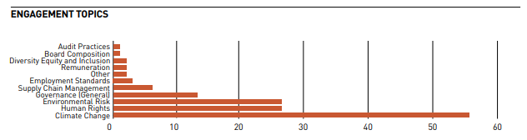

- LAPFF has been seeking meetings with companies in the oil, banking, mining and garment industries to raise important issues regarding climate, human rights, affected communities and LAPFF’s report after their visit to Brazil, remuneration and active companies in the Occupied Palestine Territories (OPT).
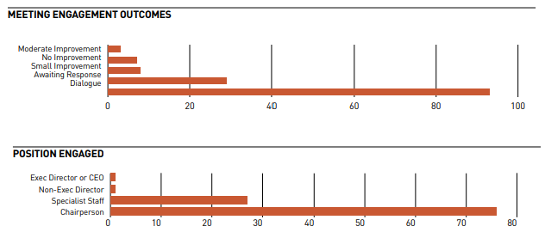

- LAPFF met with Shell’s relatively new chair, recommending voting for his re-election as he was elected after the disappointing Transition Plan 2021 and noting that Shell would be presenting a new Climate Transition Plan before the 2024 AGM. LAPFF will engage on the new Transition Plan.

- After a meeting with HSBC’s Senior Independent Director, LAPFF decided to issue a voting alert, recommending voting against the report and accounts because of inadequate human rights disclosures and the need for a broader strategy in response to the increasing integration of Hong Kong into mainland China. Climate disclosure too could be improved. The company has invited LAPFF to a follow up meeting to focus on human rights, further discussion on climate finance and reporting.

- LAPFF will follow up with Barclays on governance with one of its main concerns centred on why the Financial Conduct Authority (FCA) investigation reached a different conclusion to that of the Board a year earlier. LAPFF will also engage on climate action and disclosure, in particular the rate of wind down of fossil fuel lending.

- LAPFF has been consistently engaging with community members around the world affected by mining companies’ activities, some of them in its recent visit to Brazil. LAPFF has been seeking engagement with the mining companies, raising important issues such as social and environmental impact assessments, practices improvements, their approaches to resettlement of communities and their role in reparations for the communities, as well as engaging them in relation to LAPFF’s Brazil report.

- LAPFF continues questioning Rio Tinto’s approach to social and environmental impact assessments, which, in LAPFF’s view, need to be more methodologically rigorous, independent, and more reflective of concerns raised by affected stakeholders critical of the company’s operations.

- Anglo American engaged significantly with LAPFF in relation to the Brazil report, with LAPFF including many of the company’s useful insights and contributions in it. The Chair stated that the board would commit to visiting community members affected by Anglo American’s operations. BHP also provided helpful comments on LAPFF’s report about its visit to Brazil and offered a meeting to discuss the UK litigation pertaining to the company’s activities in relation to the Samarco tailings dam collapse.

- An ongoing area of engagement with Vale has been the time for resettling affected community members following the destruction of their homes in the tailing dam disasters. Vale indicated that, whilst still slow, progress was being made and it continues to learn, in part due to engagement it has had with LAPFF, to improve its practices.

- LAPFF met with Kingfisher in April, when company representatives provided an overview of its efforts around employee engagement and where it had provided support for its employees, with both benefits as well as salary increases. Kingfisher has paid above inflation wage increases for its lowest paid staff.

- LAPFF also met up with representatives from Bank Leumi, an Israeli bank, to encourage an independent assessment of the human rights impact of their active operations in the OPT. The LAPFF continues to push companies to discuss their approaches to human rights risk management in relation to the OPTs.

- Home Depot is alleged to have links to Uyghur forced labour in its supply chain. LAPFF asked the company to commit to a human rights assessment report. There was no commitment and LAPFF will be seeking to organise another call with the company to further discuss their supply chain due diligence.

- LAPFF met with Next and Adidas, two companies still working in Myanmar, to ask what they were doing regarding human rights risk management and due diligence. LAPFF requested Next to increase disclosure of child labour concerns and remediation practices. Adidas gave comprehensive answers to the questions and LAPFF will continue to monitor how Adidas chooses to publicise its supply chain practices, especially as it is also subject to a letter from the US House Select Committee regarding its cotton supply chain that may have links the Uyghur forced labour.

Collaborative Engagements

- CA 100+: Toyota - Transportation is a major cause of carbon emissions and therefore a strategically important sector to decarbonise. One company of concern about its lobbying alignment and its plans and targets for moving to electric vehicles has been Toyota. This quarter LAPFF signed a letter to Toyota organised by NYC Office of the Comptroller and Domini Impact Investments and supported a shareholders resolution calling for an annual review and report on the impact on Toyota caused by climaterelated lobbying activities and the alignment of their activities with the goals of the Paris Agreement. During the quarter, LAPFF also met with Toyota and covered proposed US regulations and the company’s likely position towards it. Toyota outlined capital expenditure on EVs, its plans for EV production, and discussed the challenges around battery sourcing.

- Welltower: IIRC - LAPFF is a member of the Investor Initiative for Responsible Care (IIRC), a coalition of 138 responsible and long-term investors in the care sector with $4.4 trillion in assets under management, coordinated by UNI Global Union. The initiative aims to address investment risks associated with employment and care standards within the social care sector. LAPFF wrote to Welltower, a US-based REIT, seeking a meeting and requesting the company to provide information on exposure levels and oversight mechanisms. As the company had not responded to requests for a meeting and information, LAPFF issued a voting alert and recommended voting against the chair. In total 6.9% of shareholders voted against the chair

- CA 100+: National Grid – LAPFF is one of the co-leads on National Grid at CA100+ and held several meetings to discuss concerns regarding disclosure and transition plans. The company acknowledged some of LAPFF’s comments, particularly on climate lobbying, and shortly before the AGM announced it would publish a comprehensive review of its climate lobbying activities, a key demand of LAPFF and other CA100+ members. The company publicised a policy proposal for addressing the delays in grid connection, which is broadly sensible, and a welcome development. LAPFF’s focus is on their long-term strategy and the role it sees in domestic gas, as its continuous support may explain its reluctance to embrace net zero more fully as well as the company’s own vision for improving grid connections.

- PRI Advance - LAPFF continued to engage with both the Vale and Anglo American groups through the PRI Advance initiative on human rights. LAPFF accepted the invitation to become a lead investor in the Vale group given its work in Brazil. It will continue to work with both the Vale and Anglo American groups to engage the companies and push for meaningful human rights improvements.

- 30% Club Investor Group - LAPFF continues to support the 30% Club Investor Group, a coalition of investors pushing for women to represent at least 30% of boardroom and senior management positions at FTSE-listed companies. The Group continues to extend its outreach to companies outside of the UK, with LAPFF set to lead on engagements through the Group’s Global Workstream subgroup. LAPFF met with Sanwa Holdings and Kamigumi Co in April, and although neither company is currently a member of the Japanese 30% Club Charter, both companies provided information around their diversity efforts. Stakeholder Engagement

- OECD Forum on Responsible Supply Chains - LAPFF presented at a side event of the OECD Forum on Responsible Supply Chains, aiming to share LAPFF’s learning from its visit to Brazil and its engagement with stakeholders affected by mining operations. LAPFF was approached by event participants after its presentation, who stated that they were impressed with LAPFF’s work in this area and wanted to learn more about LAPFF’s experience. LAPFF continues to engage with these contacts and others made through them to explore opportunities to develop this work stream further.

- Mining Communities and Workers - LAPFF meets with communities affected by mining operations before mining companies AGMs to listen to the communities’ experiences, understand better any operational, reputational, legal, and/or financial risks associated with its members’ investments and then present questions at AGMs and meetings. LAPFF also meets with trade union representatives and workers to inform its engagements. LAPFF met with community representatives from the US, Serbia, Madagascar, Papua New Guinea, Mexico, Peru, Colombia, and Brazil to hear about their experiences with Rio Tinto, Anglo American, and Vale. LAPFF also virtually attended a ‘pre-AGM’ meeting hosted by ShareAction and IndustriALL in relation to Glencore, where trade union leaders and community members from various countries reported their concerns about Glencore’s practices. LAPFF attended a webinar to hear about the Amazon shareholder resolution, to ensure that company practice on human rights and the environment meets community needs to create the conditions for more sustainable shareholder returns.

- Uyghur Forced Labour in Green Technology Supply Chains - The Modern Slavery and Human Rights Policy and Evidence Centre (Modern Slavery PEC) announced a project to explore and uncover links between the climate crisis and modern slavery globally. LAPFF took part in an initial consultation process where Anti-Slavery International, Sheffield Hallam University and the Investor Alliance for Human Rights are examining Uyghur forced labour in the production of green technology. LAPFF subsequently joined a two-day workshop alongside other investors and NGOs, looking at the challenges investors face in addressing these risks, engagement barriers and information gaps, before looking at ways to move forward. LAPFF is engaging with electric vehicle manufacturers on a range of issues, inclusive of human rights, and will raise these relevant supply chain issues in engagements with such manufacturers.

- Taskforce on Social Factors - LAPFF is a member of the Taskforce on Social Factors that has been established by the DWP. The taskforce has been established to look at how investors can best address and manage social factors, including by identifying reliable data and metrics. The taskforce is comprised of people from the industry and, alongside the DWP, includes observers from the Financial Conduct Authority, Financial Reporting Council, HM Treasury and the Pensions Regulator

Legal Implications

- There are no direct legal implications arising from this report.

- The terms of reference for the Board include the Board’s role as set out in the following paragraphs.

- The role of the Board, as defined by sections 5(1) and (2) of the Public Service Pensions Act 2013, is to assist the Administering Authority (London Borough of Harrow) as Scheme Manager in ensuring the effective and efficient governance and administration of the Local Government Pension Scheme (LGPS) including:
- securing compliance with the LGPS regulations and other legislation relating to the governance and administration of the LGPS;
- securing compliance with requirements imposed in relation to the LGPS by the Pensions Regulator; and
- such other matters the LGPS regulations may specify.
- The Administering Authority retains ultimate responsibility for the administration and governance of the scheme. The role of the Board is to support the Administering Authority to fulfil that responsibility.

- In its role, The Board will have oversight of the administration of the fund including:

a. The effectiveness of the decision making process
b. The direction of the Fund and its overall objectives
c. The level of transparency in the conduct of the Fund’s activities
d. The administration of benefits and contributions

- The Board will provide the Scheme Manager with such information as it requires to ensure that any Member of the Board or person to be appointed to the Board does not have a conflict of interest.

- The Board will ensure it effectively and efficiently complies with the Code of Practice on the Governance and Administration of Public Service Pension Schemes issued by the Pensions Regulator. It will help to ensure that the Fund is managed in the same way.

- The Board shall meet sufficiently regularly to discharge its duties and responsibilities effectively.

Financial Implications
- All material, financial and business issues and possibility of risks have been considered and addressed. Whilst the performance and effective controls of the fund managers is of paramount importance in the performance of the Pension Fund, there are no financial implications to the general fund arising from this report.

Risk Management Implications
- The Pension Fund’s Risk Register is reviewed regularly by both the Pension Fund Committee and by the Board.

- The level of risk to which its investments are exposed is a key component in developing the Fund’s investment strategy.

- The Pension Fund will continue to monitor the progress of the voting and engagement work carried out by the LAPFF over the medium and long term, and how this can impact investment decisions.

Equalities implications / Public Sector Equality Duty
- Was an Equality Impact Assessment carried out? No

- There are no direct equalities implications arising from this report.

Council Priorities
- The performance of the Pension Fund directly affects the level of employer contribution which then, in turn, affects the resources available for the Council’s priorities.

Section 3 - Statutory Officer Clearance

Statutory Officer: Sharon Daniels
Signed by the Chief Financial Officer

Date: 19 October 2023
Statutory Officer: Sharon Clarke
Signed on behalf of the Monitoring Officer
Date: 16 October 2023
Chief Officer: Sharon Daniels
Signed on behalf of the Corporate Director
Date: 19 October 2023

Mandatory Checks

Ward Councillors notified: Not Applicable

Section 4 - Contact Details and Background Papers
Contact: Bola Tobun – Treasury and Pensions Manager
Email: bola.Tobun@harrow.gov.uk
Telephone 020 8420 9264

Background Papers: None

